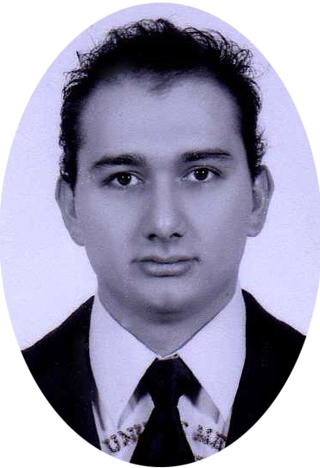
Angel De Jesús Bañuelos Sahagún
Trinidad y Tobago 259
Fracc. Sta. Cecilia
ZIP 47849
Ocotlán, Jalisco, Mex.
Cell: 0 52 1 392 100 9128
Email: ing.angel.banuelos@gmail.com

Objective
To find a challenging position to meet my competencies, capabilities, skills, education and experience.

Summary of qualifications
- Four years’ experience in Software development.
- Self-motivated; able to learn on own initiative.
- Proven ability to identify, analyze and solve problems.
- Hard worker, quick learner with ability to assume responsibilities.
- Expertise on Java technologies.
Education

- Instituto Tecnológico de Ocotlán
Period from 2007 to 2011
Career of Computer Systems with Degree in Computer System Engineer
Professional License: 7463085
- Centro de Bachillerato Tecnológico Industrial y de Servicios No. 49
Period from 2004 to 2007
Career in Computation with Degree in Computer Technician
Professional License: 6227685

PROGRAMMING SKIlLS
SQL, JAVA, PHP, ASP.NET, C#, HTML, Java-Script, Database, Visual Basic.

Professional experience

Software Engineer at HCL Technologies (August 18, 2014 - Actual)
Working as Java developer for USAA (bank services).with emphasis on: (Agile, Pair programming, Unit testing, code review).
Support, Implement and improvement in the front-end of the project using presentation services framework (Struts), creating web pages for mobile, tablet and .com. All sites created were accessibility capable. Including java script functions for interactive pages and modifying CSS.
Involved in technical training for new employees.
Tools
IBM RCA, IBM WebSphere, Charles, Chrome developer tools, Putty, IBM Rational Jazz Team, SVN. Beyond Compare.

Analyst Programmer Specialist at Sanmina (April 5, 2014 – August 18, 2014)
Arranges project requirements in programming sequence by analyzing requirements; preparing a work flow chart and diagram using knowledge of computer capabilities, subject matter, programming language, and logic.
Programs the computer by encoding project requirements in computer language; entering coded information into the computer.
Confirms program operation by conducting tests; modifying program sequence and/or codes.
Provides reference for use of prime and personal computers by writing and maintaining user documentation; maintaining a help desk.
Maintains computer systems and programming guidelines by writing and updating policies and procedures.
Maintains professional and technical knowledge by attending educational workshops; reviewing professional publications; establishing personal networks; participating in professional societies.
Protects operations by keeping information confidential.
Contributes to team effort by accomplishing related results as needed.
Develops and maintains applications and databases by evaluating client needs; analyzing requirements; developing software systems.
Tools
.Net With VB, MSSQL, MySQL, Postgresql .Net with C#, WS with J2EE, Glass Fish, Apache, Netbeans 7.0, Hibernate, Visio ‘ER’, Google Docs, Google.

IT Engineer at Sanmina (Nov 5, 2012 - April 5, 2014)
Participation in 6 sigma projects and Kaizens.
Creation of web services and servlets implementing views using JSP and JSTL.
Integrate the Model, the View, and the Controller.
Test, package and deploy Applications.
Solve problems with implemented applications. (.net, visual basic, Java, c#)
Maintenance and migration of software.
Solve user problems. (Service Request)
Data base reports production.
Creation and administration of Stores, Functions, Backups, Restores, Linked Servers, Triggers, Users, Views, jobs, Schedules etc.
Development and implementation new developments.
Tools
.Net With VB, MSSQL, MySQL, Postgresql .Net with C#, WS with J2EE, Glass Fish, Apache Netbeans 7.0, Hibernate, Visio ‘ER’.

IT Technician at Sanmina-SCI (2011 – 2012)
Software development to automate test process; Developed in Visual Basic 6.
Data Base Administration on MSSQL; Activities such as Store Procedures Creation, Triggers, Functions Views, Backups.
Software development in Java; Using threads, sockets, database connections, FTP connections, exporting reports to excel.
Different kind of reports from Data Base to Excel getting data using Macros.
IT Support.
Personnel training on software developed.
Tools
Visual Basic 6.0, MySQL, Postgresql, Java SE, Excel, .Net. with C#.

Electrical Helper at Servicios Generales BAGO (2004– 2009)
Electrical factory installations of pipes, Wire installations, Technical Support.

Languages
Spanish Native language
English Fluent / Proficient

Courses
Business Component Development with EJB Technology, Java EE 6. (Pending certification)
English Course with toefl preparation at Quick Learning (Oct, 2012 – Mar, 2014)
Fast Track SQL Server 2008 R2 at Executrain
Oracle Certified Web Component Developer at Developed Inc
Oracle Database 11g: SQL Fundamentals I at Developed Inc
Oracle Database 11g: Administrator I at Developed Inc
English Course at Proulex UDG (2006 - 2007)

Certifications

Oracle Database 11g Administrator I (1Z0-052) ORACLE ID: OC1162034.
Oracle Database 11g: SQL Fundamentals I (1Z0-051) ORACLE ID: OC1162034.
Oracle Certified Web Component Developer (1Z0-899) ORACLE ID: OC1162034.
Oracle Certified Java Programmer (1Z0-851). ORACLE ID: OC1162034.

